Java8 Exercise

1. Write the following a functional interface and implement it using lambda:
(A) First number is greater than second number or not. Parameter (int ,int ) Return boolean
Sol – Program Files Folder name – program2/Ques1A.java
interface Greater {
boolean isGreaterThan(int a,int b);
}

public class Ques1A{
public static void main(String[] args) {
int a=5,b=4;
Greater g= (x,y)-> x>y;
System.out.println(g.isGreaterThan(a,b));
}
}
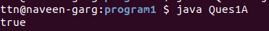

(B) Increment the number by 1 and return incremented value. Parameter (int) Return int
Sol – Program Files Folder name – program2/Ques1B.java
interface Increment {
int calculate(int a);
}
public class Ques1B{
public static void main(String[] args){
int a=10;
Increment g= (x)-> x+1;
System.out.println(g.calculate(a));
}
}
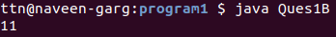

(C) Concatination of 2 string. Parameter (String , String ) Return (String)
Sol – Program Files Folder name – program2/Ques1C.java
interface Concatenate{
String operate(String a,String b);
}
public class Ques1C{
public static void main(String[] args){
Concatenate g= (x, y)-> x.concat(y);
System.out.println(g.operate("Naveen","Garg"));
}
}
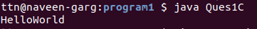

(D) Convert a string to uppercase and return . Parameter (String) Return (String)
Sol – Program Files Folder name – program2/Ques1D.java
interface UpperCase {
String operate(String a);
}
public class Ques1D{
public static void main(String[] args){
UpperCase g= (x)-> x.toUpperCase();
System.out.println(g.operate("naveengarg"));
}
}
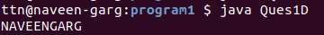

2.Create a functional interface whose method takes 2 integers and return one integer.
Sol – Program Files Folder name – program2
interface Addable{
int add(int a,int b);
}

public class Ques2{
public static void main(String[] args) {

Addable ad1=(a,b)->(a+b);
System.out.println(ad1.add(100,20));
}
}
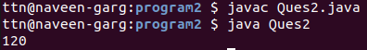

3. Using (instance) Method reference create and apply add and subtract method and using (Static) Method reference create and apply multiplication method for the functional interface created.
Sol – Program Files Folder name – program3
import java.util.function.BiFunction;
class AddSub {
public int add(int a, int b) {
return a + b;
}

public int sub(int a, int b) {
return a - b;
}
}

class Multiplication{
public static int multiply(int a, int b){
return a*b;
}
}
public class Ques3{

public static void main(String[] args) {
AddSub op = new AddSub();
System.out.println("\nUsing Instance Method Reference");
BiFunction<Integer, Integer, Integer> add2 = op::add;
System.out.println("Addtion = " + add2.apply(40, 5));

BiFunction<Integer, Integer, Integer> sub2 = op::sub;
System.out.println("Subtraction = " + sub2.apply(10, 56));

System.out.println("\nUsing Static Method Reference");
BiFunction<Integer, Integer, Integer> product = Multiplication::multiply;
int pr = product.apply(4, 8);
System.out.println("Product = "+pr);
}
}

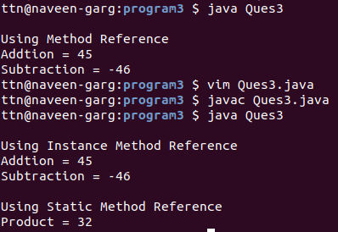

4.Create an Employee Class with instance variables (String) name, (Integer)age, (String)city and get the instance of the Class using constructor reference
Sol – Program Files Folder name – program4
interface EmployeeSupplier{
Employee get(String name,Integer age,String city);
}

class Employee{
String name;
Integer age;
String city;

public Employee(String name, Integer age, String city) {
this.name=name;
this.age=age;
this.city=city;
}

void printEmployee(){
System.out.println("Name: "+name+" Age: "+age+" City: "+city);
}
}

public class Ques4{
public static void main(String[] args) {
EmployeeSupplier supplier =Employee::new;
Employee ob=supplier.get("Naveen",24,"Delhi");
ob.printEmployee();
}
}
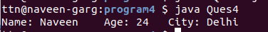

5.Implement following functional interfaces from java.util.function using lambdas:
Sol – Program Files Folder name – program5
(1) Consumer
import java.util.*;
import java.util.function.Consumer;
class Product {
private double price = 0.0;

public void setPrice(double price) {
this.price = price;
}

public void printPrice() {
System.out.println(price);
}
}

public class ConsumerQues5 {
public static void main(String[] args) {
Consumer<Product> updatePrice = p -> p.setPrice(9.9);
Product p = new Product();
updatePrice.accept(p);
p.printPrice();
}
}
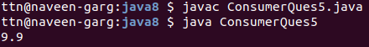

(2) Supplier
import java.util.*;
import java.util.function.Supplier;

class SupplierQues5{
public static void main(String[] args) {
int n = 10;
display(() -> n + 35);
display(() -> n + 110);
}

static void display(Supplier<Integer> arg) {
System.out.println(arg.get());
}
}
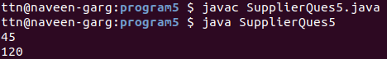

(3) Predicate
import java.util.*;
import java.util.function.Predicate;

public class PredicateQues5{
public static void main(String[] args) {
List<String> names =
Arrays.asList("Naveen","New","Akash","Xy","ToTheNew");

Predicate<String> p = (s)->s.startsWith("N");
for (String st:names)
{
if (p.test(st))
System.out.println(st);
}
}
}
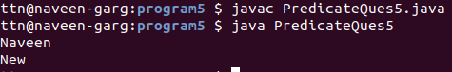

(4) Function
import java.util.*;
import java.util.function.Function;

class FuctionQues5 {
public static void main(String[] args) {
int n = 5;
modifyValue(n, val-> val + 10);
modifyValue(n, val-> val * 100);
}

public static void modifyValue(int v, Function<Integer, Integer> function){
int result = function.apply(v);
System.out.println(result);
}
}
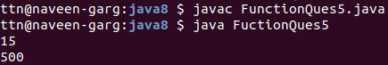

6. Create and access default and static method of an interface.
Sol – Program Files Folder name – program6
interface MyInterface{
default void newMethod(){
System.out.println("Default method");
}

static void anotherNewMethod(){
System.out.println("Static method");
}

void Display(String str);
}
public class Ques6 implements MyInterface{
public void Display(String str){
System.out.println("String is: "+str);
}

public static void main(String[] args) {
Ques6 obj = new Ques6();
obj.newMethod();
MyInterface.anotherNewMethod();
obj.Display("Java 8");

}
}
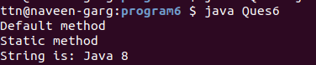

7. Override the default method of the interface.
Sol – Program Files Folder name – program7
Interfaces can have default methods with implementation in Java 8 on later.
Interfaces can have static methods as well, similar to static methods in classes.
//Code
interface MyInterface1
{
default void show()
{
System.out.println("Default MyInterface1");
}
}

interface MyInterface2
{
// override show()
default void show()
{
System.out.println("Default MyInterface2");
}
}

class Ques7 implements MyInterface1, MyInterface2
{

public void show()
{
MyInterface1.super.show();
MyInterface2.super.show();
}

public static void main(String args[])
{
Ques7 d = new Ques7();
d.show();
}
}
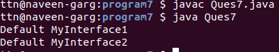

8.Implement multiple inheritance with default method inside interface.
Sol – Program Files Folder name – program8
interface ABC{
default void abc(){
System.out.println("default abc method");
}

default void print(){
System.out.println("default print abc method");
}
}

interface XYZ{
default void xyz(){
System.out.println("default xyz method");
}

default void print(){
System.out.println("default print xyz method");
}
}

public class Ques8 implements ABC, XYZ {

public void print(){
ABC.super.print();
XYZ.super.print();
}

public static void main(String[] args) {
Ques8 obj = new Ques8();
obj.abc();
obj.xyz();
obj.print();
}
}
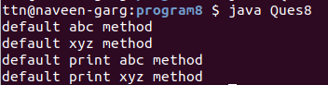

9.Collect all the even numbers from an integer list.
Sol – Program Files Folder name – program9
import java.util.Arrays;
import java.util.List;

public class Ques9 {

public static void main(String[] args) {
List<Integer> numbers = Arrays.asList(1, 2, 3, 4, 5, 6, 7, 8, 9, 10);
numbers.stream()
.filter(value -> value % 2 == 0)
.forEach(System.out::println);
}
}
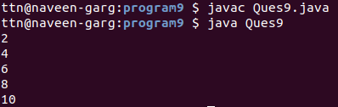

10. Sum all the numbers greater than 5 in the integer list.
Sol – Program Files Folder name – program10
import java.util.Arrays;
import java.util.List;
import java.util.*;

public class Ques10{

public static void main(String[] args) {
List<Integer> numbers = Arrays.asList(1, 2, 3, 4, 5, 6, 7, 8, 9, 10);
int total = numbers.stream().filter(value -> value > 5).mapToInt(value -> value).sum();
System.out.println("Sum all the numbers greater than 5: "+ total);
}
}
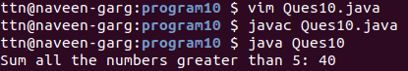

11. Find average of the number inside integer list after doubling it.
Sol – Program Files Folder name – program11
import java.util.Arrays;
import java.util.List;
import java.util.*;

public class Ques11{

public static void main(String[] args) {
List<Integer> numbers = Arrays.asList(1, 2, 3, 4, 5, 6, 7, 8, 9, 10);
double avg = numbers.stream().mapToDouble(value -> value + value).average().orElse(-1);
System.out.println("Average of the number inside integer list after doubling it: "+ avg);
}
}
12. Find the first even number in the integer list which is greater than 3.
Sol – Program Files Folder name – program12
import java.util.Arrays;
import java.util.List;

public class Ques12{

public static void main(String[] args) {
List<Integer> numbers = Arrays.asList(1, 2, 3, 4, 5, 6, 7, 8, 9, 10);
int val = numbers.stream().filter(value -> value % 2 == 0).filter(value -> value > 3).findFirst().get();
System.out.println("First even number in the integer list which is greater than 3 is "+val);
}
}

